Evaluation of the Uniting Care Wesley Bowden 2021 ‘Unplugged’ Program for Parents and Young People

August 2021

A/Prof. Daniel L. King
Mr. Alexander Phillips-Hughes
Ms. Ellie Aniulis

College of Education, Psychology, and Social Work
Flinders University

EXECUTIVE SUMMARY

Overview
This report aims to address the following research questions in regard to the Uniting Care Wesley Bowden 2021 ‘Unplugged’ program:
- What are the characteristics of parents and young people seeking educational information and/or support and strategies for managing gaming and gambling-related issues?
- To what extent are the Unplugged program participants generally aware and knowledgeable of gambling activities, and emerging digital gambling and gambling-like activities?
- To what extent are parents and young people involved in gaming and gambling activities, as well as new and emerging forms of digital gambling and gambling-like activities?
- To what extent are parents and young people experiencing problems related to involvement in gaming and gambling activities?
- To what extent are parents in the program concerned about their adolescent children being involved in gaming and gambling activities? Have they ever sought other types of external help?
- Do program participants report any changes in their understanding of and attitudes toward gambling following completion of the Unplugged program?
- To what extent are program participants satisfied with the program? Do they have any additional feedback or suggestions for improvement?

Methodology
- The research team was commissioned to evaluate the Uniting Care Wesley Bowden (UCWB) 2021 Unplugged Program. The Unplugged program is a school-based psychoeducation and prevention workshop that involves a 2-hour workshop facilitated by UCWB social workers. The program was developed in 2018 and has been delivered to more than 1000 participants since its inception.
- The program evaluation involved a pre-post research design where all participants were asked to complete a paper-and-pencil survey during the workshop.
- The survey was primarily concerned with potential changes in participants’ understanding and attitudes related to gambling activities and associated risks, and general workshop evaluation and feedback.
- A total of 188 parents and 281 adolescents returned the survey.
Results
Participant characteristics
- Parents in the Unplugged program tended to have minimal gaming experience, with only 17% who reported to play games. About half of the parents who played games also played with their child or children.
- Of the 188 parents, 50 (26.6%) reportedly did not engage in any past-year gambling activities, and 138 (73.4%) had participated in one or more gambling activities at least a few times per year.

Pre-workshop understanding of gambling and gaming
- Most parents reported feeling unsure in their understanding of skin gambling (87%), loot boxes (74%) and social casino games (48%).
- Adolescents reported similar understanding and knowledge of land-based gambling activities compared to the parent group.
- Adolescents reported greater understanding of sportsbetting than parents; 47% of adolescents understood this activity, compared with 22% of parents.
- Adolescents reported greater awareness than parents of a range of digital and online activities, including esports betting, fantasy sportsbetting, and skin gambling.
- The main differences in parents and adolescents’ understanding of gambling activities related to adolescents’ greater knowledge of new and emerging online and digital forms of gambling and gambling-like activities.

Involvement in gambling and gaming activities
- Most adolescents (i.e., 90% or more) reported that they had not been involved in any land-based forms of gambling. Among adolescents who engaged in any form of gambling, 64% reported past-year involvement in lottery products, and about a third had engaged in sportsbetting (32%) and keno or bingo (43%).
- About a third of adolescents (32%) had played video games with gambling-like content. Fewer adolescents (8.2%) reported past-year involvement in social media-based digital games (e.g., Zynga Poker).
- Most adolescents (84%) reported that they had acquired a loot box in a video game in their lifetime, with 34% reporting that they had acquired a free in-game loot box in the past 7 days.
- Adolescents reported low rates of involvement in esports betting and fantasy sports betting, with about 3% reporting lifetime involvement in these activities.
- Adolescents reported that they funded gambling using pocket money or gift money (15%). Some adolescents (7.5%) reported borrowing money, and (3.6%) reported taking money without permission (i.e., theft) to fund gambling (3.6%).
- Adolescents who had gambled reported that their gambling was enabled by a parent or guardian (15%), or relatives (11%), or a friend under the legal age to gamble (10%).

Problem gaming and gambling
- Many parents indicated that their child had gaming-related problems. There were 82 (43.6%) parents who indicated that their child met the criteria for DSM-5 gaming disorder.
- Adolescent problem gaming was prevalent and consistent with international prevalence studies (Stevens et al., 2021). There were 21 (7.5%) adolescents who met the criteria for DSM-5 gaming disorder, and 14 (4.9%) who met 3 out of 4 ICD-11 criteria and 6 (2.1%) who met all 4 criteria. Adolescents rarely endorsed any of the problem gambling indicators.
- Problem gambling rates were very low, with only 2 adolescents and 1 parent meeting the cut-off for problem gambling using PGSI and DSM measures. By comparison, 103 problem gamers were identified, including 82 adolescents as reported by parents and 21 adolescents based on their first-hand reports.

Parent concern about gambling and gaming
- Parents reported generally low concern about gambling, with the majority (82.4%) reporting “no concerns”. In comparison, parents perceived gaming as either “a problem” (22.4%) or as having “some concern” (35.6%). Most parents (82%) indicated that they had concerns about gaming, compared to only 18% for gambling.
- There was no relationship between parents’ level of understanding of gambling activities and level of concern about child involvement in gambling activities.

Workshop outcomes
- Parents reported a large, significant increase in understanding of gambling activities after completing the Unplugged workshop. Parents reported a small decease in economic perceptions of gambling, indicating that, following the workshop, parents tended to report that they viewed gambling as slightly more risky and less profitable.
- Adolescents reported a moderate, significant increase in personal understanding of gambling after the workshop. There was also a small decease in economic perceptions of gambling, indicating that adolescents tended to view gambling as slightly more risky and less profitable after the workshop. However, there were no changes in their broader attitudes towards gambling.
- There was no significant post-workshop change in parents and adolescents’ broader attitudes towards gambling.

Workshop evaluation by participants
- Parents and adolescents generally rated the workshop at a consistently high level, in terms of presentation quality, content, relevance, engagement, organisation, and speaker quality.
- Strengths of the program included: (1) entertaining and informative speakers; (2) balanced tone and helpful information explaining how gambling is introduced via gaming environments; (3) accessibility of the content to different ages and level of experience; (4) family-based strategies to support children in regulating their media use; (5) explanation of new and emerging trends in gaming and gambling; (6) case scenarios and examples; (7) the workshop enabled conversations between adolescents and parents, and (8) relevance to contemporary gaming activities.
- Practical suggestions to improve the program were: (1) expanding the scope to social media and video-streaming addictions; (2) more information regarding mental health solutions and available help services; (3) more interactive activities; (4) copies of practical materials and more case scenarios; and (5) information on gaming and brain development in children.

Summary
- Overall, the 2021 Unplugged program was well-received by participants and rated highly on all indicators, including presentation quality, content, relevance, engagement, organisation, and speaker quality.
- The survey findings suggest that parents entering the workshop have strong concerns, primarily in relation to their child’s involvement in gaming activities, and they seek practical strategies to manage these issues.
- The evaluation showed that all participants reported a significant increase in their awareness and understanding of all types of gambling activities.
- Unplugged appears to be meeting a current need for psychoeducation for parents to manage problem gaming issues, as well as facilitating a more open discussion between parents and adolescents about risky media use.
- Although the Unplugged workshop was received well by its participants, multiple improvements were identified by participants. For parents, there was feedback and suggestions related to program scope, resources and practical strategies, whereas adolescents expressed a desire for more interactivity.
- The consumer demand for and engagement with Unplugged suggests there is a need for further research and public health measures to address challenges related to online digital activities, including but not limited to gaming and gambling products.

Table of Contents

Executive Summary 2
List of tables and figures 8
- Background 9
- Description of the Program 10
- Methodology 12
- Results 14
- Main findings 46
- Conclusions 49

- List of Tables and Figures

Table 1. Demographic characteristics of the parent sample (N=185)
Table 2. Characteristics of eldest gaming child (<18 years) reported by parents
Table 3. Demographic and related characteristics of the adolescent sample (N=281)
Table 4. Gambling knowledge and awareness among parents (N=185)
Table 5. Gambling knowledge and awareness among adolescents (N=281)
Table 6. Parents’ participation in gambling activities
Table 7. Parents’ child participation in gambling activities
Table 8. Adolescents’ participation in gambling activities
Table 9. Sources of funding for gambling activities – adolescent report
Table 10. Types of social facilitation for adolescent gambling – adolescent report
Table 11. Adolescent involvement in digital games with gambling-like components
Table 12. Adolescent involvement with loot boxes and method of acquisition
Table 13. Adolescents use of loot boxes for gambling purposes
Table 14. Parents’ (n=185) problem gambling symptoms based on PGSI item responses
Table 15. Parent (n=185) ratings of problem gaming scores in reference to oldest child gamer
Table 16. Adolescents’ (n=190) problem gambling based on DSM-IV-MR-J items
Table 17. Adolescents’ (n=190) problem gaming, based on DSM-5 and ICD-11 checklists
Table 18. Parents’ concerns about child involvement in gambling and gaming activities
Table 19. Parents’ pre- and post-workshop gambling-related outcome
Table 20. Adolescents’ pre- and post-workshop gambling-related outcome
Table 21. Parents’ evaluation of the Unplugged program, part 1
Table 22. Parents’ evaluation of the Unplugged program, part 2
Table 23. Adolescents’ evaluation of the Unplugged program, part 1
Table 24. Adolescents’ evaluation of the Unplugged program, part 2

Figure 1. Parents’ mental health scores based on the Kessler-6 scale
Figure 2. Adolescents’ mental health scores based on the Kessler-6 scale
Figure 3. A comparison of parents and adolescents’ awareness and knowledge of gambling
Figure 4. Parents’ problem gambling scores, according to risk category
Figure 5. Parents’ concerns about their child’s involvement in gambling activities
Figure 6. Parents’ concerns about their child’s involvement in gaming activities
Figure 7. Parents’ help-seeking to address child’s involvement in gambling activities

1. Background
Gaming and gambling are popular recreational activities with high rates of participation in the general population. While most engage in these activities safely and experience various associated benefits, some individuals’ involvement can sometimes result in negative consequences. This is particularly well-established for gambling activities, where overinvolvement can have serious financial consequences. Research has documented negative outcomes including poor physical and mental health, low self-esteem, relationship conflict, and problems at school or work. Although gaming is generally harmless (and often beneficial) for most people, there has been recent recognition that some individuals engage in gaming excessively. Gaming disorder (GD) and hazardous gaming classifications were included in the eleventh revision of the International Classification of Diseases (ICD-11; World Health Organization, 2019). GD in the ICD-11 is characterized by persistent and recurrent gaming, impaired control over gaming, and continued gaming despite harm to multiple areas of functioning (e.g., psychological, relationship, occupational, etc.).
To date, research on interventions for gambling and gaming has had a strong focus on therapies for individuals who fall on the extreme end of the spectrum, e.g., vulnerable users with major life problems due to gaming (e.g., unemployment, disengagement from study, social isolation) (King et al., 2017; Wolfling et al., 2019). Treatments for GD have tended to be provided in countries across Europe, North America, and Asia, where much of this research has been conducted (King et al., 2018; Liu, Nie, & Wang, 2017), and usually with a focus on cognitive-behavioral therapies and other psychotherapies (King et al., 2017; Stevens, Dorstyn, Delfabbro, & King, 2019). Other treatment and support modalities include peer supports, such as through Computer Gamers Anonymous (https://cgaa.info/) and GameQuitters (https://gamequitters.com/), and group therapies at hospitals and universities. In Australia, despite local interest, there has been a lack of universal prevention initiatives, particularly for young likely to engage in online gaming activities and who may be exposed to opportunities to participate in associated gambling activities (e.g., esports betting).
In this context, relatively little research has focused on prevention and harm minimization options for less serious cases or ‘low risk’ cases, e.g., to prevent gaming-related problems from becoming more serious in nature. To meet a current need for primary prevention for gambling and gaming-related issues among young people, UnitingCare Wesley Bowden has developed a school-based program that involves providing information to parents and students about technology use, including gaming and gambling. This project involves an independent evaluation of the workshop, which aims to examine the effectiveness of the program in modifying participants’ understanding and knowledge of gambling and gaming activities, including ‘crossover’ activities facilitated online, and identify the relative strengths and potential limitations of the program in achieving its broad objectives.

2. Description of the Program
The Unplugged program was developed by Uniting Care Wesley Bowden (UCWB) in 2018 through a process of internal development and consultation with local and overseas consultants. The primary aim of the program was to deliver accessible and practical information about gaming and gambling activities and provide participants with strategies for managing their online activities. The program was initially designed to focus primarily on gaming but was revised to include coverage of topics including gambling, particularly digital gambling activities that intersect with online gaming. The program content has been regularly updated to accommodate emerging developments in the areas of gaming and gambling.
Uniting Care Wesley Bowden were commissioned to provide twenty-four, free, 2-hour workshops across a 12-month period in 2021, following a previous successful rollout of the program in 2019. The workshop is structured to include information for both parents and young people regarding the links between gaming and problem gambling, offer strategies to manage risk, and provide advice on where to seek more information and support.

Topics in the Unplugged workshop:
- Problematic gaming and its impacts
- Gaming-gambling convergence
- Potential link between problematic gaming and future gambling behaviours
- The changing gaming landscape and increasing gambling presence in games
- Online activities available to young people and how they can be accessed and financed
- Healthy internet/online use
- Creating balance by promoting alternate interests
- Creating healthy boundaries with gaming/gambling
- Building positive parent/child relationships
- Developing understanding that gaming and gambling industries are businesses with primary intentions of making profits and do not consider long term consequences of players
- Strategies to reduce problematic gaming and potential development to problematic gambling.

Participants are provided with information packs containing relevant information, strategies and where to go for additional supports (including young mental health services, Relationship Australia SA's StepUp program and UCWB). Promotion and participant engagement occurs primarily through schools, sporting groups, community organisations and other child and youth focused wellbeing services. A direct approach was taken to contact relevant organisations via email offering to provide the program to their community. This included a detailed brochure outlining the program and inviting their participation. All email correspondence was followed up with phone calls. A face-to-face meeting or information session for relevant staff was provided at the organisation's request.
Interested organisations were enlisted to provide an appropriate venue that is easily accessible to parents and young people within their community. Appropriate dates and times to run workshops were then determined in partnership with the participating organisation and UCWB. UCWB provide a flyer for distribution to parents and young people and an article for inclusion in their newsletter. The event was posted on the UCWB Facebook page which can be shared on the organisations own social media platform. The interpreter symbol was included in information and promotional material where applicable.
Unplugged workshop participants were given the opportunity to participate in a further workshop delivered by UCWB titled ‘Engaging Adolescents’. This workshop is designed to assist parents to engage with their teenager in healthy and constructive ways, build a relationship with their teenager and deal with unacceptable behaviour. The strategies taught in Engaging Adolescents will complement those delivered in Unplugged workshops. Engaging Adolescents will be run four times during the school year and be targeted to parents who have attended an Unplugged workshop. Engaging Adolescents is run over three, two-hour sessions and provides parents with easy techniques they can use to support their adolescent/s to manage behaviour problems and emotional reactions. In the event that issues escalate in the home with regard to young people becoming violent, refusing to attend school, or presenting other challenging behaviours the family is referred to Relationship Australia SA's StepUp to Gaming program.
Unplugged was supported by an active and supportive online presence via a closed Facebook group accessible to parents and young people who have attended an Unplugged workshop. The group provides a place for parents to ask questions and seek support from Uniting Care Wesley Bowden's social workers as well as other parents, and create a community of sharing issues and successes. Uniting Care Wesley Bowden will use the platform to publish up-to-date and relevant articles and information, share relevant and timely strategies based on emerging trends and issues, and facilitate group discussions. The group was moderated by Uniting Care Wesley Bowden social workers and supported by administration support who refer any parent or young person at risk to a relevant pathway, including to Relationship Australia SA's StepUp to Gaming program.

3. Methodology
All participants of the Unplugged program were administered a survey package in pen-and-paper format upon entry to the workshop. The survey was completed in two parts: Part 1 contained questions about background and current knowledge and participation in gaming and gambling activities, and questions about personal concerns and support for gaming and gambling issues, and Part 2 contained questions to assess post-workshop understanding and attitudes related to gambling, and general workshop evaluation and feedback questions.
There was a parent and adolescent version of the survey, with the parent survey including self-referential questions and questions referring to their oldest non-adult child who plays video games. The adolescent survey included questions referring to their own experiences only. Each survey comprised approximately 50 questions, requiring 15-20 minutes to complete, and mostly including standard measures of gaming and gambling-related behaviour and attitudes, which were largely consistent across the two versions of the survey.

Measures
Sociodemographic information was gathered, included: age (in years), gender (male/female/other), school grade, ethnicity, employment status, home living situation, and postcode. Additional questions will ask about frequency of electronic media use, hours per week spent on gaming and social media.
The following questions were administered In Part 1 and 2: (1) familiarity and knowledge of gambling activities, which is a list of 13 gambling activities accompanied by a 4-point scale from “Unsure what it is” to “I understand it”; (2) the Attitudes toward Gambling scale, an 8-item measure to assess attitudes toward and general acceptance/tolerance of gambling; and (3) Economic Perceptions of Gambling survey, which assesses perceptions of the profitability and risk of gambling activities. These measures have been used in many previous Australian studies of gambling involvement to evaluate general community attitudes toward gambling.
Additional frequency measures for gaming and gambling activities were asked. These questions provide a standard list of activities and ask participants to indicate participation and age of first involvement in each activity, and future intentions to participate. Adolescents were asked to report if they had been involved with family assistance. Some questions asked about spending money on gaming and related activities (e.g., loot boxes).
Screening measures of problematic gaming and gambling were administered. These measures were commonly used measures, including Petry’s (2014) screening measure to assess problematic gaming tendencies, supplemented by questions based on the ICD-11 gaming disorder criteria. The DSM-IV-TR problem gambling screen (adolescents) and the PGSI (adults) was used. The K6 screener for general mood complaints was used.
The final measure of the survey was a general feedback and rating measure. Questions ask participants to rate the usefulness of the content, the quality of the speakers and content, whether they would recommend the program, and to give an overall rating of the program. There are options to provide written feedback in comment boxes.

Procedure
Data collection was facilitated by UCWB staff during each workshop. Surveys were provided to participants at the beginning of each workshop and then collected at the end. Surveys were anonymous and were not labelled or otherwise identified in relation to any of the schools or other settings where the workshop was held. Surveys were provided to the research team and manually entered into SPSS Statistics package and then stored in a locked office at Flinders University. Data entry and analysis was conducted by two research assistants with psychology training.

Ethics approval
This project was approved by the Human Research Ethics Subcommittee in the School of Psychology at the University of Adelaide (approval ID: 20/84) and by the Department of Education (approval ID: 2020-0062).
4. Results

Research Question 1:
What are the characteristics of parents and young people seeking educational information and/or support and strategies for managing gaming and gambling-related issues?

Parent sample
Table 1 presents a summary of the demographic characteristics of the parent sample (N=185). The parents were over-represented in terms of female gender (61%) and tended to belong to the 41–50-year-old age category and the ‘Australian’ category (NB: this is a standard category used by the Australian Bureau of Statistics). In terms of other characteristics, 161 participants (85.6%) were employed (either casual, part-time, or full-time), with 12.8% unemployed (N=12.8%).

Table 1. Demographic characteristics of the parent sample (N=185)
 |  | N (%)
Gender | Female | 115 (61.2%)
 | Male | 69 (36.7%)
 | Non-binary | 1 (0.5%)
Age | 30-40 | 3 (16%)
 | 41-50 | 114 (60.6%)
 | 51-60 | 33 (17.7%)
 | 60+ | 8 (4.3%)
Ethnicity | Aboriginal/TSI | 1 (0.5%)
 | Australian | 123 (65.4%)
 | Asian | 38 (20.2%)
 | European | 19 (10.1%)
 | Other | 3 (1.6%)

Most parents reported minimal video-gaming experience. A total of 32 parents (17% of the sample) indicated that they currently played video games, with a mean time spent gaming of 1.1 hours per week (SD=2.91). Half of these parents (n=16) reported to play games with their child or children, and another 10 parents played with their child/children and on their own. In relation to social media use, there were 19 parents who reported they did not use social media. Parents reported spending an average of 6.5 hours per week on social media.
As shown in Figure 1, parents’ mental health status was measured by the Kessler-6 scale. The results indicated a negatively skewed distribution which is typically expected for the normal population. Based on 166 responses, participants’ average score was 10.4 (SD=4.1). Kessler et al. (2010) indicated that scores ranging between 6 and 18 have no probable serious mental illness, while scores between 19 and 30 indicate probable serious mental illness. The minimum score was 6, maximum score was 25. Results indicate that only 6 individuals (3.6%) scored in the range of 19+, indicating a likelihood of serious mental illness.

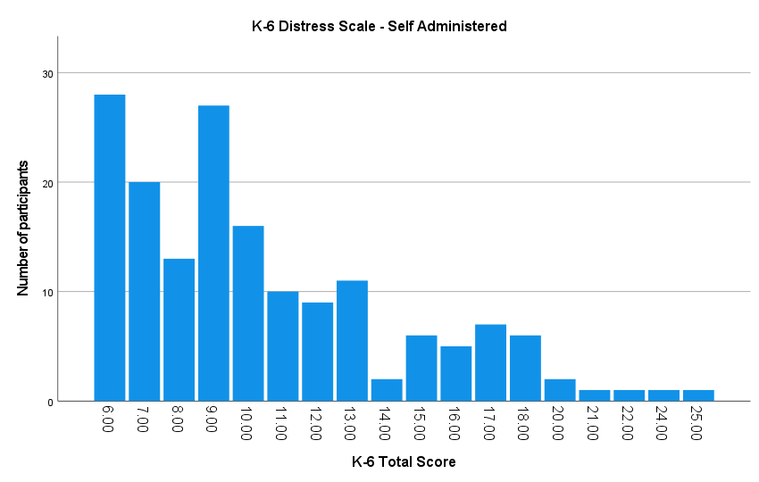

Figure 1. Parents’ mental health scores based on the Kessler-6 scale

Table 2 presents a summary of the characteristics of parents’ eldest child under the age of 18 years and who played video games. About three-quarters (76%) of these children were male, with an average age of 13 years. Parents reported that this child played video games, on average, for 13 hours per week and spend an average of 5 hours on social media.
Most of these children had access to a laptop (85%) and a smartphone (86%), followed by a gaming console (70%). About 1 in 9 children had access to a virtual reality headset.

Table 2. Characteristics of eldest gaming child (<18 years) reported by parents
 |  | N (%)
Gender | Female | 37 (19.7%)
 | Male | 144 (76.6%)
 | Non-binary | 2 (1.1%)
Devices at home | PC | 63 (33.5%)
 | Laptop | 161 (85.6%)
 | VR headset | 23 (12.2%)
 | Smartphone | 162 (86.2%)
 | Gaming console | 133 (70.7%)
 | Tablet | 107 (56.9%)
 | Other | 7 (3.7%)
 |  | M | SD
Age | Average | 13.2 | 2.55
Device use (hours) | Gaming | 13.3 | 11.13
 | Social media | 5.42 | 7.04

Adolescent sample
Table 3 presents a summary of the demographic and related characteristics of the adolescent sample (N=281). The adolescents were over-represented in terms of male gender (88%). The mean age of this group was 13 years, with most participants in either Grade 8 or 10 (thus, the sample was largely aged 12 and 14 years), and they tended to belong to the ‘Australian’ category (59%), followed by the Asian (15%) and European (12%) categories. Adolescents tended to report that they lived with both parents (77%). Most participants (84.6%) were not employed.

Table 3. Demographic and related characteristics of the adolescent sample (N=281)
 |  | N (%)
Gender | Female | 15 (5.3%)
 | Male | 246 (87.5%)
 | Non-binary | 9 (3.2%)
Age | Average | 13.85 (1.76)
Ethnicity | Aboriginal/TSI | 5 (1.8%)
 | Australian | 166 (59.1%)
 | Asian | 43 (15.3%)
 | European | 35 (12.5%)
 | Other | 22 (7.8%)
School Grade | 5 | 1 (0.4%)
 | 6 | 3 (1.1%)
 | 7 | 24 (8.5%)
 | 8 | 116 (41.3%)
 | 9 | 9 (3.2%)
 | 10 | 97 (34.5%)
 | 11 | 3 (1.1%)
 | 12 | 1 (0.4%)
Employment | Employed | 40 (14.2%)
 | Unemployed | 228 (81.1%)
Living situation | Parents together | 217 (77.2%)
 | Divorced/separated | 47 (16.7%)
 | Other | - (2.1%)

Figure 2 displays the results of the mental health screener for the adolescent sample. Of 211 responses, participants scored an average of 10.34 (SD=4.03) out of 30 on the self-reported K-6 distress scale. Generally, these results were consistent with the parent sample, demonstrating a positive skew toward non-problem scores. Kessler et al. (2010) indicated that scores ranging between 6 and 18 have no probable serious mental illness, while scores between 19 and 30 indicate probable serious mental illness. The minimum score was 6 and the maximum score was 25. Results indicated that 8 individuals (3.8%) scored 19 or greater, indicating a likelihood of serious mental illness.
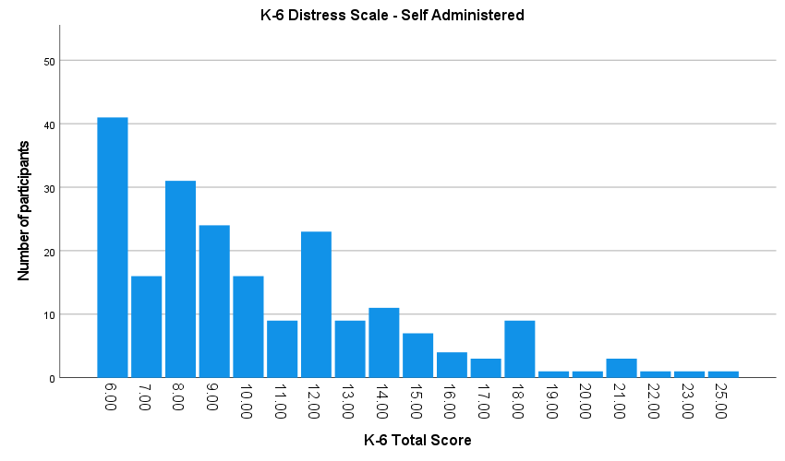
Figure 2. Adolescents’ mental health scores based on the Kessler-6 scale

Research Question 2:
To what extent are the Unplugged program participants generally aware and knowledgeable of gambling activities, and emerging digital gambling and gambling-like activities?

Parent sample
Table 4 provides a summary of parents’ responses to questions about their level of understanding of a range of gambling activities. It bears noting that these questions employed response categories that referred to “understanding” as the highest possible response (indicating knowledge), whereas “awareness” referred to being familiar with the activity without any greater knowledge. Gambling activities included traditional land-based activities, as well as a variety of digital and online activities and emerging gambling-like activities that are available in some online gaming activities. For clarity, all references to ‘gaming’ and ‘game’ refer to video-gaming (not gambling). In general, parents reported greater awareness and understanding of the conventional, land-based forms of gambling such as pokies and keno/bingo, and less awareness for emerging forms such as skin gambling and buying loot boxes. The most well-understood activities were pokies and lottery products, followed by casino card games and gambling on the races. Relatively few parents reported to understand skin gambling, loot boxes and other digital gambling-like products.

Table 4. Gambling knowledge and awareness among parents (N=185)
 | Understand  N (%) | Know a little  N (%) | Awareness  N (%) | Unsure  N (%) | Mean
Pokies/poker machines | 103 (54.8%) | 41 (21.8%) | 29 (15.4%) | 13 (6.9%) | 3.26
Horses/greyhound | 70 (37.2%) | 43 (22.9%) | 59 (31.4%) | 14 (7.4%) | 2.91
Scratchies, lotto or pools | 107 (56.9%) | 48 (25.5%) | 21 (11.2%) | 10 (5.3%) | 3.35
Keno/Bingo | 98 (52.1%) | 39 (20.7%) | 36 (19.1%) | 13 (6.9%) | 3.19
Poker | 57 (30.3%) | 54 (28.7%) | 57 (30.3%) | 16 (8.5%) | 2.83
Blackjack/roulette | 54 (28.7%) | 51 (27.1%) | 54 (28.7%) | 25 (13.3%) | 2.73
Sports betting | 43 (22.9%) | 36 (19.1%) | 83 (44.1%) | 23 (12.2%) | 2.54
Esports betting | 20 (10.6%) | 28 (14.9%) | 76 (40.4%) | 62 (33%) | 2.03
Fantasy sports betting | 12 (6.4%) | 25 (13.3%) | 66 (35.1%) | 83 (44.1%) | 1.82
Skin gambling | 8 (4.3%) | 1 (0.5%) | 11 (5.9%) | 165 (87.8%) | 1.22
Buying loot boxes | 15 (8%) | 14 (7.4%) | 17 (9%) | 140 (74.5%) | 1.48
Social casino games | 16 (8.5%) | 19 (10.1%) | 60 (31.9%) | 91 (48.4%) | 1.78

Adolescent sample
Table 5 provides a summary of adolescents’ level of understanding of a range of gambling activities. In general, adolescents reported a level of awareness and understanding of the conventional, land-based forms of gambling that was comparable to the parent sample. The most well-understood activities were lottery products and keno or bingo, followed by sportsbetting and pokies. About a third of adolescents understood casino card games and gambling on the races. A significant minority (i.e., about a third of the sample) reported to understand esports betting and loot boxes.

Table 5. Gambling knowledge and awareness among adolescents (N=281)
 | Understand  N (%) | Know a little  N (%) | Awareness  N (%) | Unsure  N (%) | Mean
Pokies/poker machines | 114 (40.6%) | 65 (23.1%) | 80 (28.5%) | 15 (5.3%) | 3.01
Horses/greyhound | 103 (36.7%) | 74 (26.3%) | 77 (27.4%) | 20 (7.1%) | 2.95
Scratchies, lotto or pools | 141 (50.2%) | 62 (22.1%) | 54 (19.2%) | 15 (5.3) | 3.21
Keno/Bingo | 160 (56.9%) | 53 (18.9%) | 52 (18.5%) | 11 (3.9%) | 3.31
Poker | 98 (34.9%) | 67 (23.8%) | 81 (28.8%) | 26 (9.3%) | 2.87
Blackjack/roulette | 102 (36.3%) | 64 (22.8%) | 65 (23.1%) | 43 (15.3%) | 2.82
Sportsbetting | 132 (47%) | 68 (24.2%) | 63 (22.4%) | 12 (4.3%) | 3.16
Esports betting | 86 (30.6%) | 53 (18.9%) | 81 (28.8%) | 53 (18.9%) | 2.63
Fantasy sports betting | 74 (26.3%) | 37 (13.2%) | 76 (27%) | 86 (30.6%) | 2.36
Skin gambling | 37 (13.2%) | 28 (10%) | 37 (13.2%) | 169 (60.1%) | 1.75
Buying loot boxes | 94 (33.5%) | 35 (12.5%) | 58 (20.6%) | 84 (29.9%) | 2.51
Social casino games | 77 (27.4%) | 64 (22.8%) | 66 (23.5%) | 66 (23.5%) | 2.56

Figure 3. A comparison of parents and adolescents’ awareness and knowledge of gambling

Parents and adolescents reported comparable levels of awareness and knowledge of most land-based activities; specifically, there were no significant differences in reported knowledge of betting on horses, lottery products, poker, and blackjack/roulette. However, adolescents reported greater awareness of sportsbetting activities than parents (47% understood this activity, compared with 22%), which was statistically significant (t=6.88, p<05). Similarly, independent-samples t-tests showed that adolescents reported greater awareness than parents of a range of digital and online activities, including esports betting, fantasy sportsbetting, and skin gambling (t=5.59-6.27, p<05). Further, adolescents were more aware and had greater understanding than parents of loot box purchases and social casino games (t=7.89-10.01, p<05), with a large effect size. Overall, the largest difference in parents and adolescents’ understanding of gambling activities related to adolescents’ greater knowledge of new and emerging digital forms of gambling and gambling-like activities.

Research Question 3:
To what extent are parents and young people involved in gaming and gambling activities, as well as new and emerging forms of digital gambling and gambling-like activities?

Parent sample
Table 6 presents a summary of parents’ involvement in various gambling activities. Of 188 participants, 50 (26.6%) reportedly did not engage in any gambling activities, and 138 (73.4%) had participated in one or more gambling activities at least a few times per year. Among parents who engaged in any form of gambling, 95% reported past-year involvement in lottery products, and about a third had engaged in pokies (35%) and betting on horses (37%). About 1 in 5 parents (19.6%) who gambled on any activity reported to gamble on informal private gambling activities (card or dice games).
The most commonly reported activity among parents was lottery products (48%), with the most typical pattern of use being “a few times per year”. Lottery products were the only activity engaged in weekly, with all other activities reported as less frequent (i.e., once a month or more rarely). About one quarter of the sample had played the pokies in the past year. Very few parents had experience in esports betting (n=3) or fantasy sports (n=1).

Table 6. Parents’ participation in gambling activities
 | Never | A few times per year | About once every month | Weekly | Any involvement  (total)
Pokies or poker machines | 138 (73.4%) | 46 (24.5%) | 2 (1.1%) | - | 48 (25.6%)
Horse or greyhound races | 135 (71.8%) | 45 (23.9%) | 6 (3.2%) | - | 51 (27.1%)
Scratchies, lottery, lotto or pool tickets | 55 (29.3%) | 91 (48.4%) | 22 (11.7%) | 18 (9.6%) | 131 (69.7%)
Keno or bingo | 146 (77.7%) | 39 (20.7%) | 1 (0.5%) | - | 40 (21.2%)
Poker online or in a pub, club or casino | 176 (93.6%) | 9 (4.8%) | 1 (0.5%) | - | 10 (5.3%)
Casino table games (Blackjack or Roulette) | 152 (80.9%) | 33 (17.6%) | 1 (0.5%) | - | 34 (18.1%)
Sporting events | 162 (86.2%) | 20 (10.6%) | 4 (2.1%) | - | 24 (12.7%)
Esports events | 182 (96.8%) | 3 (1.6%) |  | - | 3 (1.6%)
Fantasy sports games | 185 (98.4%) | 1 (0.5%) |  | - | 1 (0.5%)
Informal private games | 159 (84.6%) | 26 (13.8%) | 1 (0.5%) | - | 27 (14.3%)

Table 7 presents a summary of parents’ reports of their oldest gaming child’s lifetime involvement in gambling activities. In general, parents reported that their oldest gaming child had not engaged in any regular gambling activities. The most common activity was lottery products (n=16) and keno or bingo (n=8). None of the parents reported that their child or any of their children was involved in esports betting or fantasy sports.

Table 7. Parents’ child participation in gambling activities
Which of the following gambling activities,  to your knowledge, has your child  participated in using real money? | N (%)
Pokies or poker machines | 3 (1.6%)
Horse or greyhound races | 6 (3.2%)
Scratchies, lottery, lotto or pool tickets | 16 (8.5%)
Keno or bingo | 8 (4.3%)
Poker online or in a pub, club or casino | 1 (0.5%)
Casino table games (Blackjack or Roulette) | 2 (1.1%)
Sporting events | 4 (2.1%)
Esports events (e.g. CS-GO,  League of Legends or DOTA2) | -
Fantasy sports games (e.g. NFL fantasy football) | -
Informal private games (e.g. card or dice games) | 10 (5.3%)

Adolescent sample
Table 8 presents a summary of the adolescent sample’s involvement in gambling activities. Most participants (i.e., 90% or more) reported that they had not been involved in any land-based forms of gambling. Among adolescents who engaged in any form of gambling, 64% reported past-year involvement in lottery products, and about a third had engaged in sportsbetting (32%) and keno or bingo (43%).
The most common activity was lottery products (16%), followed by sportsbetting (8%). A similar proportion of the sample reported past-year informal private gambling activities. Adolescent participants reported similarly low rates of involvement in esports betting and fantasy sports betting, with about 3% reporting any lifetime involvement in these activities.
Adolescents also reported the age at which they first engaged in each gambling activity, if applicable. These ages of initiation varied from 9.5 to 14 years, but were based on a small sample and had large standard deviations. The youngest age of initiation was for esports betting (9.5 years) and fantasy sports betting (10.8 years), and the oldest was poker (13.2 years) and pokies (14.0 years).

Table 8. Adolescents’ participation in gambling activities
 | Never | 12+ months ago | In last 12 months | In the last 4 weeks | In the last 7 days | Any involvement  N (%)
Pokies or poker machines | 259 (92.2%) | 5 (1.8%) | 3 (1.1%) | 1 (0.4%) | 2 (0.7%) | 11 (4%)
Horse or greyhound races | 254 (90.4%) | 10 (3.6%) | 4 (1.4%) | 1 (0.4%) | 2 (0.7%) | 17 (6.1%)
Scratchies, lottery, lotto or pool tickets | 224 (79.7%) | 15 (5.3%) | 21 (7.5%) | 8 (2.8%) | 2 (0.7%) | 46 (16.3%)
Keno or bingo | 238 (84.7%) | 9 (3.2%) | 17 (6%) | 4 (1.4%) | 1 (0.4%) | 31 (11%)
Poker online or in a pub, club or casino | 261 (92.9%) | - | 7 (2.5%) | 1 (0.4%) | 2 (0.7%) | 10 (3.6%)
Casino table games (Blackjack or Roulette) | 253 (90%) | 7 (2.5%) | 6 (2.1%) | 1 (0.4%) | 3 (1.1%) | 17 (6.1%)
Sporting events | 246 (87.5%) | 10 (3.6%) | 7 (2.5%) | 1 (0.4%) | 5 (1.8%) | 23 (8.3%)
eSports events (e.g. CS-GO, League of Legends or DOTA2) | 259 (92.2%) | 4 (1.4%) | 3 (1.1%) | 1 (0.4%) | 2 (0.7%) | 10 (3.6%)
Fantasy sports games (e.g. NFL fantasy football) | 260 (92.5%) | 7 (2.5%) | - | 1 (0.4%) | 2 (0.7%) | 10 (3.6%)
Informal private games (e.g. card or dice games) | 220 (78.3%) | 9 (3.2%) | 22 (7.8%) | 10 (3.6%) | 7 (2.5%) | 48 (17.1%)

Table 9 presents a summary of the adolescent sample’s reported financial sources for gambling activities. The most common source of funding was pocket money or gift money (15%). Some adolescents (7.5%) reported borrowing money to fund their gambling, and some participants (3.6%) reported taking money without permission (i.e., theft) to fund gambling.

Table 9. Sources of funding for gambling activities – adolescent report
 | N (%)
Money from a job | 16 (5.7%)
Pocket money/gift money | 43 (15.3%)
Money given by parents/guardians intended for something else | 29 (10.3%)
Money given by parents/guardians for gambling | 14 (5%)
Money from selling belongings | 16 (5.7%)
Money borrowed with permission | 21 (7.5%)
Money or items took without permission | 10 (3.6%)
Other | 2 (0.7%)

Table 10 reports the types of social facilitators for adolescent gambling. Most adolescent participants reported that their gambling had been enabled by a parent or guardian (15%), followed by other relatives (11%) or a friend under the legal age to gamble (10%). Gambling with the assistance of a friend over the age of 18 years was less common than other types of gambling facilitators. Only 2 adolescents reported that they gambled on their own, without any assistance from others.

Table 10. Types of social facilitation for adolescent gambling – adolescent report
 | N (%)
Parents/guardians | 43 (15.3%)
Relatives 18+ | 30 (10.7%)
Relatives <18 | 22 (7.8%)
Friends 18+ | 16 (5.7%)
Friends <18 | 28 (10%)
None, I usually gamble alone | 2 (0.7%)
Other | 6 (2.1%)
I do not gamble | 183 (65.1%)
NB: % refers to the total sample of adolescents.

Adolescents were asked a series of questions about their involvement in various digital gambling and gambling-like activities. Table 11 provides a summary of adolescent involvement in a variety of digital games with gambling-like features. The most common past-year activity was playing video games with gambling-like content, which was reported by 32% of adolescents. A small proportion (8.2%) reported past-year involvement in social media-based digital games (e.g., Zynga Poker).
Table 12 shows that adolescents engaged with loot boxes in different ways and to varying degrees. Most respondents (84%) reported that they had acquired a loot box in a video game in their lifetime, with 34% reporting that they had acquired a free in-game loot box in the past 7 days. About half (49.8%) had spent real money to acquire a loot box, with 10% of participants reporting they had done so in the past month. In relation to in-game purchases, 117 participants (41.6%) reported to have bought loot boxes for cosmetic items or ‘skins’, 161 (57.3%) has made purchases for in-game progress or to acquire competitive items, and 107 (38.1%) made purchases for in-game currency which may serve multiple in-game functions.
Table 13 presents a summary of the adolescents’ reported involvement in different gambling activities facilitated by or otherwise implicated by the interaction with loot boxes. About 10% of adolescents reported that they had engaged in skin betting activities in connection with loot box content, and about 8% had engaged in esports betting using loot box content. The most common activity was private betting using loot box content, which was reported by 16% of the sample. Overall, these findings suggest that there is a minority of young people who engage or have previously engaged in various digital forms of gambling, some of which is made accessible via monetised content in video games.

Table 11. Adolescent involvement in digital games with gambling-like components
 | Never | 12+ months ago | In last 12 months | In the last 4 weeks | In the last 7 days
Social media (e.g., Zynga) | 209 (74.4%) | 6 (2.1%) | 3 (1.1%) | 6 (2.1%) | 14 (5%)
Video games | 142 (50.5%) | 5 (1.8%) | 24 (8.5%) | 20 (7.1%) | 46 (16.4%)
Free demo or practice games | 188 (66.9%) | 14 (5%) | 10 (3.6%) | 14 (5%) | 11 (3.9%)
Gambling-themed apps | 187 (66.5%) | 9 (3.2%) | 17 (6%) | 8 (2.8%) | 17 (6%)

Table 12. Adolescent involvement with loot boxes and method of acquisition
 | Never | 12+ months ago | In last 12 months | In the last 4 weeks | In the last 7 days
Free in game | 44 (15.7%) | 22 (7.8%) | 40 (14.2%) | 38 (13.5%) | 96 (34.2%)
Spending real money | 141 (50.2%) | 31 (11%) | 39 (13.9%) | 13 (4.6%) | 15 (5.3%)
Virtual currency purchased with real money | 126 (44.8%) | 26 (9.3%) | 41 (14.6%) | 19 (6.8%) | 25 (8.9%)

Table 13. Adolescents use of loot boxes for gambling purposes
 | Never | 12+ months ago | In last 12 months | In the last 4 weeks | In the last 7 days
Skin betting | 194 (69%) | 4 (1.4%) | 7 (2.5%) | 10 (3.6%) | 8 (2.8%)
eSports betting | 201 (71.5%) | 3 (1.1%) | 10 (3.6%) | 3 (1.1%) | 6 (2.1%)
Other events or sports | 200 (71.2%) | 1 (0.4%) | 13 (4.6%) | 3 (1.1%) | 6 (2.1%)
Private betting with friends | 175 (62.3%) | 13 (4.6%) | 15 (5.3%) | 6 (2.1%) | 12 (4.3%)

Research Question 4:
To what extent are parents and young people experiencing problems related to involvement in gaming and gambling activities?

Parent sample
Parents were administered the Problem Gambling Severity Index (PGSI) to screen for potential gambling problems. Table 14 presents a summary of the group’s responses to each PGSI item. Parents generally selected the ‘never’ category in response to each item, with at least 93% of the sample selecting this response for each item. The mean PGSI score was 0.24 (SD=1.56), which is very low. The PGSI indicates that a total score of 0 indicates non-problem gambling, 1-2 indicates a low risk of problems with few or no identified negative consequences, a score of 3-7 indicates a moderate risk gambler, and scores of 8+ indicate problem gambling with negative consequences and a possible loss of control.
Overall, as indicated in Figure 4, there were 171 participants in the non-problem category, 5 participants in the low-risk category, 3 participants in the moderate risk category and 1 participant scored as a problem gambler. These results suggest that the adult sample reported gambling problems at a lower rate than the general Australian population, where problem gambling is typically estimated to have a prevalence rate of about 1%.
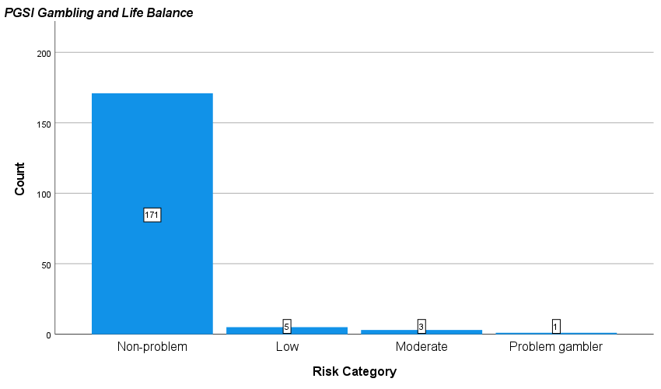
Figure 4. Parents’ problem gambling scores, according to risk category
Table 14. Parents’ (n=185) problem gambling symptoms based on PGSI item responses
 | Never | Rarely/Sometimes | Most of the time | Always | Mean (SD)
Bet more than you can really afford to lose? | 179 (95.2%) | 2 (1.1%) | 1 (0.5%) | - | 0.02 (0.18)
Needed to gamble with larger amounts of money to get the same feeling of excitement? | 177 (94.1%) | 3 (1.6%) | 1 (0.5%) | - | 0.03 (0.2)
Gone back another day to try and win back the money you lost? | 179 (95.2%) | 1 (0.5%) | 1 (0.5%) | - | 0.02 (0.17)
Borrowed money or sold anything to get money to gamble? | 180 (95.7%) | 1 (0.5%) | - | - | 0.01 (0.07)
Felt you might have a problem with gambling? | 179 (95.2%) | 1 (0.5%) | 1 (0.5%) | - | 0.02 (0.24)
Felt that gambling has caused you health problems, including stress and anxiety? | 176 (93.6%) | 1 (0.5%) | 1 (0.5%) | - | 0.05 (0.36)
People criticised your betting or told you that you have a gambling problem (regardless of whether you thought this true)? | 185 (95.7%) | 1 (0.5%) | - | - | 0.01 (0.07)
Felt your gambling has caused financial problems for you or your household? | 177 (94.1%) | 1 (0.5%) | 2 (1.1%) | 1 (0.5%) | 0.04 (0.31)
Felt guilty about the way you gamble or what happens when you gamble? | 177 (94.1%) | 1 (0.5%) | 1 (0.5%) | 2 (1.1%) | 0.05 (0.35)

The parent sample also answered questions related to problem gaming (i.e., video games) in relation to their oldest, non-adult-aged child who plays video games. These questions were drawn from two screening items to assess problem gaming, which are based on the DSM-5 and ICD-11 criteria for gaming disorder, respectively. These items are similar conceptually to items on the PGSI, being based on criteria for an addictive disorder. Table 15 presents a summary of these two screening tools, with the DSM-5 items (n=9) presented first, followed by the ICD-11 items (n=4). In terms of scoring, for the DSM-5 items, a score of 5 or more (i.e., each ‘yes’ response is scored ‘1’) indicates problem gaming. For the ICD-11 items, there is currently no agreed scoring method for this measure, with two potential scoring approaches currently under consideration in the literature.
Overall, of the 188 respondents, there were 82 (43.6%) parents whose responses indicated that their child met the criteria for DSM-5 gaming disorder. The ICD-11 screening items have higher specificity (or, lower sensitivity) and there were 65 (34.6%) who met 3 out of 4 criteria and 15 (8%) who met all 4 criteria. This variability (8-43%) in problem gaming rates aligns with known issues of consistency in gaming disorder prevalence studies (Stevens, Dorstyn, Delfabbro, 2021).

Table 15. Parent (n=185) ratings of problem gaming scores in reference to oldest child gamer
In the past 12 months… | Yes (%)
Did your child spend a lot of time thinking about games even when he/ was not playing, or planning when you could play next? | 115 (61.2%)
Did your child feel restless, irritable, moody, angry, anxious or sad when attempting to cut down or stop gaming, or when unable to play? | 125 (66.5%)
Did your child feel the need to play for increasing amounts of time? | 115 61.2%)
Was your child unable to control how much he/she played games? | 93 (49.5%)
Did your child lose interest in or reduce participation in other recreational activities (hobbies, meetings with friends) due to gaming? | 86 (45.7%)
Did your child continue to play games despite being aware of negative consequences, such as not getting enough sleep, being late to school/work, having arguments with others, or neglecting important duties? | 90 (47.9%)
Did your child lie to family, friends or others about time spent gaming, or try to keep family or friends from knowing how much time was spent gaming? | 54 (28.7%)
Did your child game to escape from or forget about personal problems, or to relieve uncomfortable feelings such as anxiety or depression? | 37 (19.7%)
Did your child risk or lose significant relationships or educational or sport opportunities because of gaming? | 32 (17%)
Have you regularly found it hard to control how often or how long your child plays video games? | 101 (53.7%)
Has your child increasingly prioritised playing video games over other important activities? | 95 (50.5%)
Has your child’s video gaming caused problems in your life? (e.g., with your parents/family, school, work, general health) | 63 (33.5%)
Has your child continued to play video games despite experiencing problems? | 66 (35.1%)

Adolescent sample
Adolescents were administered the Problem Gambling Severity Index (PGSI) to screen for potential gambling problems. Table 16 presents a summary of the group’s responses to each DSM-IV-MR-J item. Adolescents tended to select the ‘never’ category in response to each item. With the exception of the preoccupation (Item 1) question which tends to record higher scores in survey studies due to its sensitivity (e.g., it can measure future plans to gamble rather than current gambling behaviour), at least 76% of participants recorded a ‘never’ response to any given item. The cut-off for potentially problem gambling status on the DSM-IV-MR-J is 4 out of 9 criteria. Following this scoring method, there were only 2 (0.7%) adolescents who met the criteria for problem gambling. With very low rates of endorsement, it is difficult to exclude the possibility that affirmative responses may be the product of error, misunderstanding, or mischievous responding in studies of young people.

Table 16. Adolescents’ (n=190) problem gambling based on DSM-IV-MR-J items
How often in the last 12 months have you? | Never | Once or twice | Sometimes | Often | Mean (SD)
How often have you found yourself thinking about gambling or planning to gamble? | 149 (53%) | 47 (16.7%) | 13 (4.6%) | 3 (1.1%) | .39 (0.69)
Have you needed to gamble with more and more money to get the amount of excitement you want? | 219 (77.9%) | 10 (3.6%) | - | - | .04 (0.21)
Have you ever spent much more than you planned to on gambling? | 222 (79%) | 3 (1.1%) | 3 (1.1%) | 1 (0.4%) | .05 (0.32)
Have you felt bad or fed up when trying to cut down or stop gambling? | 216 (76.9%) | 4 (1.4%) | 2 (0.7%) | 2 (0.7%) | .06 (0.36)
How often have you gambled to help you to escape from problems or when you are feeling bad? | 221 (78.6%) | 5 (1.8%) | - | 1 (0.4%) | .04 (0.25)
After losing money gambling, have you returned another day to try and win back money you lost? | 216 (76.9%) | 5 (1.8%) | 4 (1.4%) | 2 (0.7%) | .08 (0.41)
Has your gambling ever led to lies to your family? | 222 (79%) | 2 (0.7%) | 2 (0.7%) | 1 (0.4%) | .04 (0.29)
Have you ever taken money from the following without permission to spend on gambling? | 223 (79.4%) | 2 (0.7%) | 1 (0.4%) | 1 (0.4%) | .03 (0.26)
Has your gambling ever led to arguments with family or friends or others? | 218 (77.6%) | 8 (2.8%) | - | 1 (0.4%) | .05 (0.27)
Adolescents responded to the same questions related to problem gaming (i.e., video games) as those administered to the parent sample. Table 17 presents a summary of these two screening tools, with the DSM-5 items (n=9) presented first, followed by the ICD-11 items (n=4). Overall, there were 21 (7.5%) adolescents who met the criteria for DSM-5 gaming disorder, and 14 (4.9%) who met 3 out of 4 ICD-11 criteria and 6 (2.1%) who met all 4 criteria.

Table 17. Adolescents’ (n=190) problem gaming, based on DSM-5 and ICD-11 checklists
During the last 12 months: (Yes/No) | Yes (%)
Did you spend a lot of time thinking about games even when he/ was not playing, or planning when you could play next? | 94 (33.5%)
Did you feel restless, irritable, moody, angry, anxious or sad when attempting to cut down or stop gaming, or when unable to play? | 26 (9.3%)
Did you feel the need to play for increasing amounts of time? | 38 (13.5%)
Were you unable to control how much he/she played games? | 48 (17.1%)
Did you lose interest in or reduce participation in other recreational activities (hobbies, meetings with friends) due to gaming? | 15 (5.3%)
Did you continue to play games despite being aware of negative consequences, such as not getting enough sleep, being late to school/work, having arguments with others, or neglecting important duties? | 60 (21.4%)
Did you lie to family, friends or others about time spent gaming, or try to keep family or friends from knowing how much time was spent gaming? | 24 (8.5%)
Did you game to escape from or forget about personal problems, or to relieve uncomfortable feelings such as anxiety or depression? | 65 (23.1%)
Did you risk or lose significant relationships or educational or sport opportunities because of gaming? | 5 (1.8%)
Have you regularly found it hard to control how often or how long you play video games? | 41 (14.6%)
Have you increasingly prioritised playing video games over other important activities? | 27 (9.6%)
Has your video gaming caused problems in your life? (e.g., with your parents/family, school, work, general health) | 27 (9.6%)
Have you continued to play video games despite experiencing problems? | 33 (11.7%)

Research Question 5:
To what extent are parents in the program concerned about their adolescent children being involved in gaming and gambling activities? Have they ever sought other types of external help?

Parents expressed varying levels of concern about their child’s involvement in gaming and gambling activities. As shown in Table 18 and Figures 5 and 6, parents reported relatively low concern about gambling, with the majority (82.4%) reporting “no concerns”. In comparison, parents perceived gaming as either “a problem” (22.4%) or as having “some concern” (35.6%). Only 18% of parents indicated that they had no concerns about gaming. An independent samples t-test showed that parents were significantly more concerned about gaming than gambling (t[166]=15.5, p<01) with a large effect size (Cohen’s d =1.2). Further analyses showed that there was no significant relationship between parents’ level of understanding of gambling activities and level of concern about child involvement in gambling.

Table 18. Parents’ concerns about child involvement in gambling and gaming activities
 | No concerns  N (%) | Aware, but harmless  N (%) | Some concern  N (%) | It is a problem  N (%) | Mean
Gambling | 155 (82.4%) | 5 (2.7%) | 8 (4.3%) | 12 (6.4%) | 0.32 (0.842)
Gaming | 33 (17.6%) | 29 (15.4%) | 67 (35.6%) | 42 (22.3%) | 1.69 (1.05)
(0=no concern, 1=Aware, but harmless, 2=Some concern, 3= it is a problem)
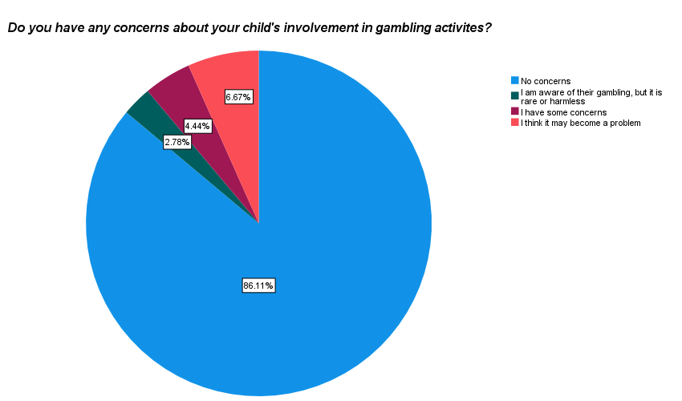

Figure 5 Parents’ concerns about their child’s involvement in gambling activities

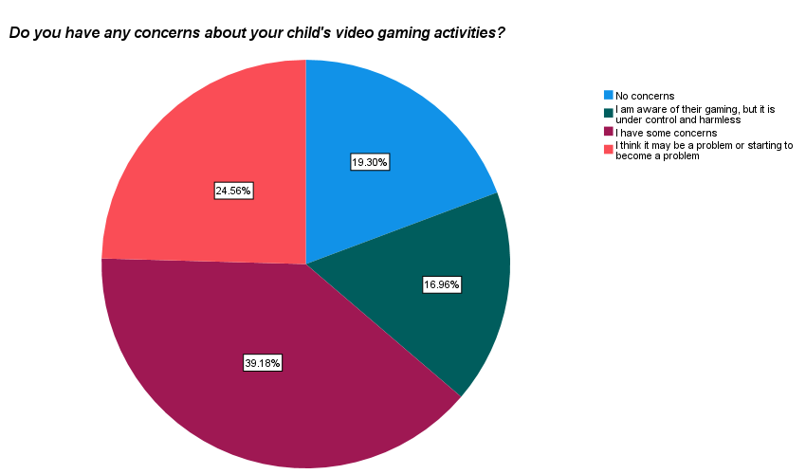

Figure 6. Parents’ concerns about their child’s involvement in gaming activities

Parents were asked whether they had ever sought some form of support to address their child’s gaming-related issues. As shown in Figure 7, there were 50 parents (31.9%) who had sought help before, and an additional 32 parents (17%) who had considered seeking support. Among the 50 participants whose child had sought support for problem gaming, 30 (60%) reported having found it helpful.

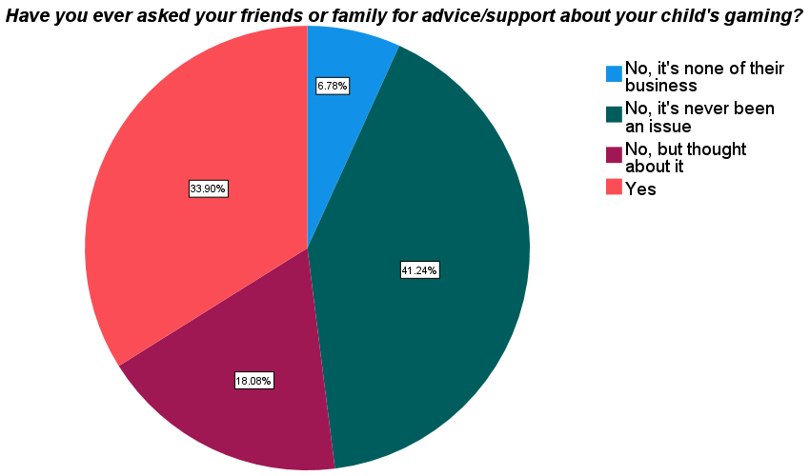
Figure 7. Parents’ help-seeking to address child’s involvement in gambling activities

Research Question 6
Do program participants report any changes in their understanding of and attitudes toward gambling following completion of the Unplugged program?
Parent sample
All participants were asked to evaluate the Unplugged program according to three main gambling-related outcomes: (1) their personal understanding (familiarity/knowledge) of gambling activities; (2) their attitudes toward gambling (i.e., whether they tended to hold favourable or unfavourable views about gambling); and (3) economic perceptions of gambling (i.e., views about the financial risks and long-term profitability of gambling activities).
Table 19 presents a summary of parents’ pre- (i.e., baseline) and post-workshop ratings of each of the gambling-related outcomes. The analysis showed that, post-workshop, there was a large, significant increase in personal understanding of gambling activities. There was also a small decease in economic perceptions of gambling, indicating that, after the workshop, parents tended to report that they viewed gambling as slightly more risky and less profitable. However, there was no significant change in their broader attitudes towards gambling.

Adolescent sample
Table 20 presents a summary of adolescents’ pre- (i.e., baseline) and post-workshop ratings of each of the gambling-related outcomes. Notably, at baseline, adolescents reported similar mean scores to parents on the measures of personal understanding and attitudes toward gambling, but adolescents reported a slightly greater tendency toward viewing gambling as a profitable activity. The analysis showed that there was a moderate, significant increase in personal understanding of gambling after the workshop. There was also a small decease in economic perceptions of gambling, indicating that adolescents tended to view gambling as slightly more risky and less profitable after the workshop. However, there were no changes in their broader attitudes towards gambling.
Taken together, these results indicate that both parents and adolescents reported a significant increase in their understanding of gambling activities following the workshop and a small but significant reduction in perceptions of gambling as a profitable activity. The workshop did not appear to modify broader attitudes toward gambling activities.

Table 19. Parents’ pre- and post-workshop gambling-related outcome
 | Baseline | Post-Workshop | N | 95% CI Lower | 95% CI Upper | t | df | p | Effect size
Familiarity/Knowledge of Gambling | 29.74 (7.88) | 40.96 (7.95) | 155 | -12.49 | -9.96 | -17.5 | 154 | <.01 | -1.41
Attitudes Toward Gambling | 23.56 (3.85) | 23.26 (3.77) | 159 | -0.44 | 1.04 | 0.81 | 158 | 0.42 | 0.06
Economic Perceptions of Gambling | 13.93 (4.87) | 12.48 (4.82) | 163 | 0.83 | 2.07 | 4.59 | 162 | <.01 | 0.36

Table 20. Adolescents’ pre- and post-workshop gambling-related outcome
 | Baseline | Post-Workshop | N | 95% CI Lower | 95% CI Upper | t | df | p | Effect size
Familiarity/Knowledge of Gambling | 32.78 (9.38) | 37.75 (9.75) | 186 | -6.05 | -3.88 | -9.02 | 185 | <.01 | -0.66
Attitudes Toward Gambling | 23.57 (3.05) | 22.59 (3.90) | 180 | 0.38 | 1.56 | 3.25 | 179 | <.01 | 0.24
Economic Perceptions of Gambling | 19.09 (6.11) | 18.14 (6.74) | 181 | 0.26 | 1.65 | 2.70 | 180 | <.01 | 0.20

Research Question 7:
To what extent are program participants satisfied with the program? Do they have any additional feedback or suggestions for improvement?

Parent sample
Parents were asked to evaluate the workshop on multiple factors (e.g., presentation quality, content, relevance, engagement, organisation, and speaker qualities). Overall, as indicated in Table 21, participants (n=162-166) rated the workshop at a consistently high level, indicating that, on average, they agreed or strongly agreed with all statement indicators of workshop quality. As shown in Figure 7, most parents reported that the program was the ideal length (90%), with only some participants reporting it was too long (8%) or too short (1%).

Table 21 Parents’ evaluation of the Unplugged program, part 1
Workshop evaluation | N | Mean | SD
1. The program content matched the description | 162 | 4.34 | .83
2. The program was relevant to me | 164 | 4.07 | .95
3. I now better understand the risks of gambling | 163 | 4.39 | .84
4. I would recommend the program to other people | 166 | 4.34 | .81
5. The program was well paced and interesting | 165 | 4.22 | .82
6. The instructors were engaging communicators | 167 | 4.26 | .87
7. The material was presented in an organised manner | 166 | 4.39 | .77
8. The presenters were knowledgeable on the topic | 166 | 4.53 | .71
** 1=Strongly disagree, 5=Strongly agree
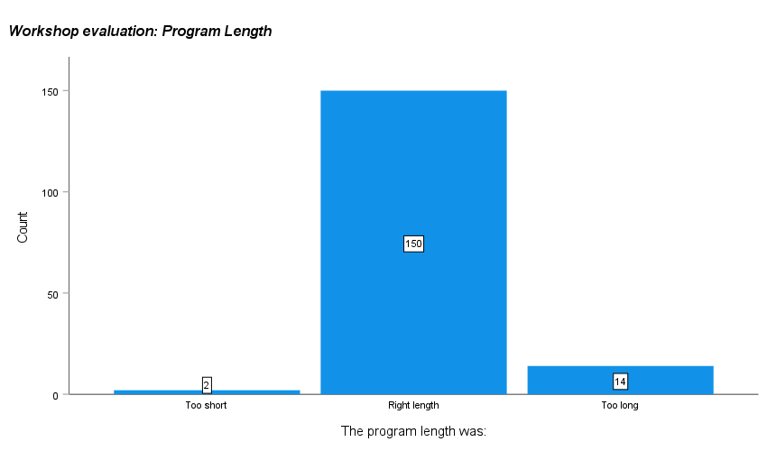
Figure 7. Parents’ evaluation of the length (duration) of the Unplugged program
Table 22 provides some additional evaluation about the program in four broad areas: (1) presenters; (2) program content; (3) handouts; and (4) the program overall. Overall, the parents rated Unplugged very highly across all four areas, with mean ratings falling just below the highest possible rating of “Excellent”.

Table 22. Parents’ evaluation of the Unplugged program, part 2
 | N | Mean score | SD
Presenters | 167 | 3.34 | 0.71
Program content | 166 | 3.28 | 0.75
Handouts | 165 | 3.13 | 0.74
Program overall | 165 | 3.21 | 0.74
*1=Poor, 4=Excellent

Adolescent sample
Adolescents were asked to evaluate the workshop on multiple factors (e.g., presentation quality, content, relevance, engagement, organisation, and speaker qualities). Overall, as indicated in Table 23, adolescent participants (n=188-189) rated the workshop at a consistently high level, indicating that, on average, they tended to agree with all statement indicators of workshop quality. As per Figure 8, most adolescents reported that the program was the ideal length (69%), however some participants felt that it was too long (34%).

Table 23. Adolescents’ evaluation of the Unplugged program, part 1
Workshop evaluation | N | Mean Score | SD
1. The program content matched the description | 188 | 4.12 | 0.85
2. The program was relevant to me | 189 | 3.31 | 1.22
3. I now better understand the risks of gambling | 189 | 4.02 | 1.09
4. I would recommend the program to other people | 189 | 3.80 | 1.15
5. The program was well paced and interesting | 189 | 3.68 | 1.15
6. The instructors were engaging communicators | 190 | 3.87 | 1.03
7. The material was presented in an organised manner | 189 | 4.00 | 0.95
8. The presenters were knowledgeable on the topic | 188 | 4.22 | 0.94
** 1=Strongly disagree, 5=Strongly agree

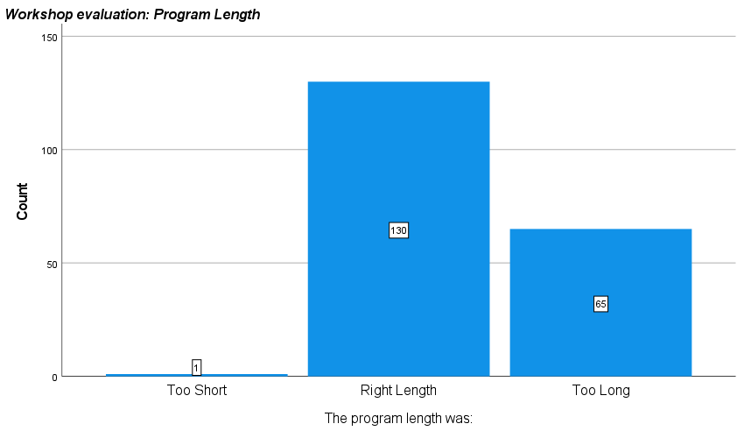
Figure 8. Adolescents’ evaluation of the length (duration) of the Unplugged program

Table 24 provides some additional evaluation about the program in four broad areas: (1) presenters; (2) program content; (3) handouts; and (4) the program overall. Overall, the adolescents rated Unplugged highly across all four areas, with mean ratings consistently falling into the ‘Great’ category.

Table 24. Adolescents’ evaluation of the Unplugged program, part 2
Please rate the following: | N | Mean score | SD
Presenters | 192 | 3.28 | 0.8
Program content | 192 | 2.99 | 0.88
Handouts | 190 | 2.81 | 0.91
Program overall | 193 | 3.01 | 0.88
**1=Poor, 4=Excellent

All participants were invited to provide further feedback on the Unplugged workshop via written responses to open questions. Two questions were presented to assess: (1) the participant’s personal highlight of the program or the aspect of the program considered to be most effective or enjoyable; and (2) some suggestions for ways in which the program could be improved. Each response was transcribed exactly as it appeared in the survey.
A sample of some of these written responses, highlighting the variety of perspectives and practical suggestions is provided below. Each quote is accompanied by the gender (F=Female, M=Male, X=Non-binary or unspecified) and age of participant.

Parent sample
What did you appreciate/enjoy/think was best about the UNPLUGGED workshop?
- “Discussion of negative effects. Thank you, excellent!” -X, 41-50
- “Actually learning about the gambling side of gaming as I hadn't really realised it was happening” -F, 41-50
- “Understanding how gambling is introduced into the gaming environment – scary” -M, 41-50
- “Content was relevant and highlighted changes we can make to support my children become more 'unplugged'”- F, 41-50
- “Tips for decreasing gaming and increasing family time” -F, 30-40
- “Seeing Cam's story. Understanding hidden gambling aspects. Understanding gaming personalities.” -M, 41-50
- “It gave me a starting point and insight to be able to guide my son on gaming restrictions” F, 51-60
- “The presenter was young and did a great job with parents in the audience. I am better informed and feel better able to have better conversations with my children.” -F, 41-50
- “As a parent of a child just beginning to become curious with online gaming, it good to be aware of red flags to look out for” -F, 30-40
- “Understanding the enjoyment/social aspect kids get from gaming as opposed to the 'screen time' and not moving their bodies outside in nature. That gaming is a fun thing to do with friends.” -F, 30-40

The written feedback highlighted the following strengths or positive aspects of the program: (1) New information explaining how gambling is introduced via gaming environments in subtle and hidden ways; (2) that the program highlighted changes and strategies parents can implement to support children in regulating their media use; (3) Explanation of new and emerging trends in gaming and gambling; (4) the focus on ‘family-based’ approaches to implementing strategies; (5) the content was informative and relevant to both parent and child level, and that the workshop included adolescent attendees.

Do you have any suggestions for improvement?
- “Would be great to have a copy of the presenters slides in the pack” -F, 41-50
- “More information regarding mental health solutions” -F, 41-50
- “Interactive activities for the students to work together” -F, 41-50
- “The gambling part was interesting but younger kids zoned out as it was a bit irrelevant in their eyes. Maybe mix it up a bit more so gaming still seems like the focus.” -F, 41-50
- “Getting kids to give their feedback!” -F, 41-50
- “A handout especially for children can be given at the end to each child having all the 'DON'T DO ACTIVITIES' with strong recommendations to put on their bedroom wall.” -M, 41-50
- “Additional content on gaming over gambling. Also social media - warning signs of issues. IT tools to limit access etc.” -M, 41-50
- “More info on how to talk to kids about changing their habits/gaming behaviour” -F, 41-50

The written feedback highlighted the following suggestions on ways to potentially modify or refine the program: (1) expand the scope of content to include discussion of social media/YouTube/Facebook addictions; (2) provide more information regarding mental health solutions; (3) facilitate more interactive activities and group discussions; (3) provide a copy of PowerPoint slides to those seeking them; (4) more thorough definitions on emerging forms of gaming; (5) information on the potential effects of gaming on brain development in children; (6) having multiple presenters to vary the presentation; (7) include more case scenarios or examples of how gaming and gambling has negative consequences; and (8) provide more information on help services for problem gambling or gaming and related mental health help.

Adolescent sample
What did you appreciate/enjoy/think was best about the UNPLUGGED workshop?
- “Acknowledging that gaming is okay and not just a useless addiction” -M, 15
- “How it shows both the positives and negatives of gaming and explains all forms of gambling clearly” -M, 13
- “Mum understood more things from my life from this seminar. I don't know how to talk about this stuff.” -M, 13
- “Extremely informative, fun, interactive and organised. The instructor was amazing and everything was amazing” -M, 13
- “It's relevance to me and how engaging it was” -M, 15
- “…I'm now more aware of risks involved with gaming and gambling” -M, 14
- “It explained the possibilities of gambling and talks of the fact that some can be affected more than others.” -M, 13
- “How they included games we actually play nowadays…” -M, 13
- “It shows latent gambling in video games. I will be more aware in the future, thanks to this :)” -M, 15

The written feedback highlighted the following strengths or positive aspects of the program: (1) explanation of links between gaming and gambling and associated risks; (2) the balanced approach to discussion, noting that gaming is not inherently harmful or “bad”; (3) the speakers were entertaining and informative; (4) the coverage of different types of gambling and its newer forms; (5) content was accessible to parents which provided them more insight into adolescent’s life and what they value in gaming activities; (6) the use of case scenarios and examples; (7) explanations of addiction and its risks and harms; (8) that content enabled conversations between adolescents and parents about online activities, and (9) relevant references to contemporary gaming activities.
Adolescents provided relatively less feedback in relation to improvements to the Unplugged program. The main practical suggestions were: (1) making the program more interactive with the audience; (2) program content to address the social pressures and social perceptions of gaming in more detail, and (3) reducing the length of the evaluation survey.

5. Main Findings
This evaluation of the UCWB 2021 Unplugged workshop yielded the following main observations and findings:

Participant characteristics
- Parents in the Unplugged program tended to have minimal gaming experience, with only 17% who reported to play games.
- Most parents reported that their child (or one of their children) had access to a laptop (85%), a smartphone (86%), and a gaming console (70%). About 1 in 9 children had access to a virtual reality headset.
- Of the 188 parents, 50 (26.6%) reportedly did not engage in any past-year gambling activities, and 138 (73.4%) had participated in one or more gambling activities at least a few times per year.
- Most parents reported that, to their knowledge, their oldest gaming child had not engaged in any regular gambling activities.

Pre-workshop understanding of gambling and gaming
- Before completing the workshop, most parents (about 50-70%, depending on the activity) reported that they understood or knew a little about conventional, land-based gambling such as pokies and keno or bingo.
- Most parents reporting feeling unsure in their understanding of skin gambling (87%), loot boxes (74%) and social casino games (48%).
- Adolescents reported similar understanding of land-based gambling activities to parents, while reporting greater understanding of sportsbetting than parents (47% of adolescents understood this activity, compared with 22% of parents).
- Adolescents reported greater awareness than parents of a range of digital and online activities, including esports betting, fantasy sportsbetting, and skin gambling.
- Adolescents demonstrated greater knowledge than parents of new and emerging online and digital forms of gambling and gambling-like activities.

Involvement in gambling and gaming activities
- None of the parents reported that their oldest gaming child was involved in esports betting or fantasy sports.
- Most adolescents (i.e., 90% or more) reported that they had not been involved in any land-based forms of gambling. Among adolescents who engaged in any form of gambling, 64% reported past-year involvement in lottery products, and about a third had engaged in sportsbetting (32%) and keno or bingo (43%).
- About a third of adolescents (32%) had played video games with gambling-like content, and 8.2% reported past-year involvement in social media-based digital games (e.g., Zynga Poker).
- Most adolescents (84%) reported that they had acquired a loot box in a video game in their lifetime, including 34% who had done so in the past 7 days.
- About half (49.8%) had spent real money to acquire a loot box, with 10% of participants reporting they had done so in the past month.
- About 10% of adolescents reported that they had engaged in skin betting activities using loot box content.
- Adolescents reported low rates of involvement in esports betting and fantasy sports betting, with about 3% reporting lifetime involvement in these activities.
- Adolescents reported that they funded gambling using pocket money or gift money (15%). Some adolescents (7.5%) reported borrowing money, and (3.6%) reported taking money without permission (i.e., theft) to fund gambling (3.6%).

Problem gaming and gambling
- Very few parents endorsed PGSI problem gaming indicators. There were 171 in the non-problem category, 5 low-risk, 3 at moderate risk and 1 problem gambler.
- Many parents indicated that their child had gaming-related problems. There were 82 (43.6%) parents who indicated that their child met the criteria for gaming disorder.
- Adolescents rarely endorsed any problem gambling indicators. In the adolescent sample, only 2 (0.7%) adolescents who met the criteria for problem gambling.
- Adolescent problem gaming (video-games) was consistent with international prevalence studies (Stevens et al., 2021). There were 21 (7.5%) adolescents who met the criteria for DSM-5 gaming disorder.
- Problem gambling rates were very low, with only 2 adolescents and 1 parent meeting the cut-off for problem gambling. By comparison, 103 problem gamers were identified, including 82 adolescents as reported by parents and 21 adolescents based on their first-hand reports.

Parent concern about gambling and gaming
- Parents reported generally low concern about gambling, with the majority (82.4%) reporting “no concerns”. In comparison, parents perceived gaming as either “a problem” (22.4%) or as having “some concern” (35.6%). Only 18% of parents indicated that they had no concerns about gaming, compared to 82% for gambling.
- There were 50 parents (31.9%) who had sought help for gaming-related issues, and an additional 32 parents (17%) who had considered seeking support.
- There was no relationship between parents’ level of understanding of gambling activities and level of concern about child involvement in gambling activities.

Workshop outcomes
- Parents reported a large, significant increase in understanding of gambling activities after completing the Unplugged workshop.
- Parents reported a small post-workshop decease in economic risk perceptions of gambling.
- Adolescents reported a moderate, significant increase in personal understanding of gambling after the workshop. There was also a small decease in economic perceptions of gambling. However, there were no changes in their broader attitudes towards gambling.
- There was no significant post-workshop change in parents and adolescents’ broader attitudes towards gambling.

Workshop evaluation by participants
- Parents and adolescents rated the workshop highly, in terms of presentation quality, content, relevance, engagement, organisation, and speaker quality.
- Most parents reported that the program was the ideal length (90%); a minority of participants reported it was too long (8%) or too short (1%).
- Most adolescents reported that the program was the ideal length (69%), or that it was too long (34%).
- Parents and adolescents rated the programs’ presenters, program content, and handouts at a high level, close to ‘excellent’.
- Parent-identified strengths of the program included: (1) information explaining how gambling is introduced via gaming environments; (2) strategies to support children in regulating their media use; (3) explanation of new and emerging trends in gaming and gambling; (4) ‘family-based’ approaches to implementing strategies; and (5) the content was appropriate for families of most ages.
- Parents’ practical suggestions to improve the program included: (1) expand the scope to social media and video-streaming addictions; (2) more information regarding mental health solutions; (3) more interactive activities; (4) provide a copy of slides; (5) better definitions on emerging forms of gaming; (6) information on gaming and brain development in children; (7) more presenters for variety; (8) more case scenarios; and (9) further information on help services.
- Adolescent-identified strengths of the program included: (1) explanation of gaming-gambling links and associated risks; (2) the balanced approach; (3) the speakers were entertaining and informative; (4) the coverage of different types of gambling and its newer forms; (5) content was accessible to parents and gave them more insight into adolescent’s life and what they value in gaming activities; (6) case scenarios and examples; (7) explanations of addiction; (8) content enabled conversations between adolescents and parents, and (9) relevance to contemporary gaming.

6. Conclusions
Overall, the 2021 Unplugged program was well-received by participants and rated highly on all indicators, including presentation quality, content, relevance, engagement, organisation, and speaker quality. The survey findings suggest that parents entering the workshop have strong concerns primarily about gaming and they seek practical strategies to manage these issues. These data indicate that problem gaming was relatively more common among participants in the program, as compared to gambling difficulties which were quite rare. Although the Unplugged program has a strong focus on gaming and gaming-gambling links, and less of a focus on conventional forms of gambling, the evaluation showed that all participants reported a significant increase in their awareness and understanding of all types of gambling activities. However, the evaluation did not identify significant changes in participants’ attitudes toward gambling and risk perceptions of gambling, which is understandable given the brief format of the program.
In conclusion, the workshop appears to be meeting a significant current need for psychoeducation for parents to manage problem gaming issues, as well as facilitating a more open discussion between parents and adolescents about risky media use. This evaluation also highlighted some practical steps to improve the workshop in its current format, while pointing to the broader need for deeper evaluation of the online risks related to gaming and gambling hybrid activities. Further research and public health measures appear warranted to better understand and meet the complex challenges and needs of individuals, families, and communities experiencing myriad difficulties related to excessive use of various online digital activities, including but not limited to gaming and gambling products.

